# Lab: REST Services

Problems for in-class lab for the "[JavaScript Applications" course @ SoftUni](https://softuni.bg/opencourses/js-apps).

**1. Darth Vader Response**

**NOTE: Install** "[Postman](https://www.getpostman.com/)" REST Client to **ease** your tasks.

Your first task is to get detailed information about Darth Vader.

* Send a "**GET**" request to the link given below.
* **Copy** the response in JSON format.

**REQUEST**:

https://swapi.co/api/people/4



**RESPONSE**:

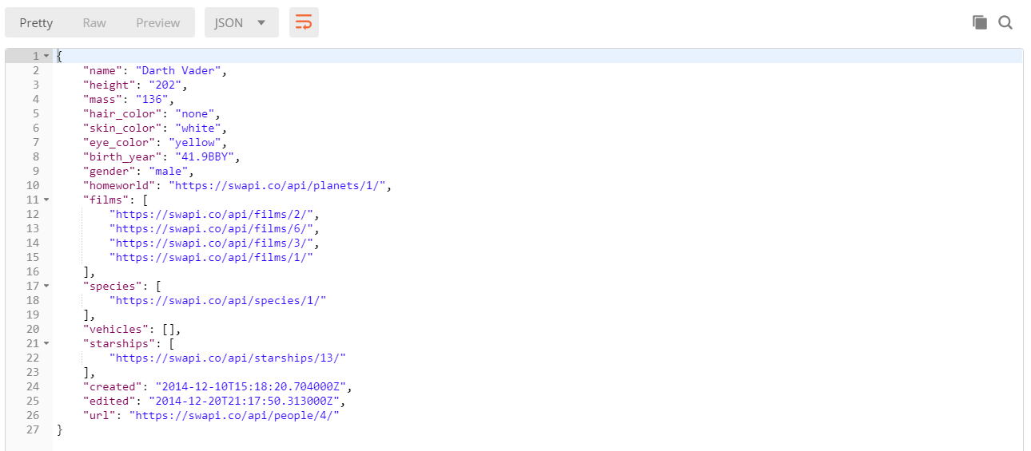

**2. GitHub: Labels Issue**

Get the **first** issue from repository with **name** “test-nakov-repo”. Send a GET request to https://api.github.com/repos/testnakov/test-nakov-repo/issues/:id, where :id is the issue.

**3. Github: Create Issue**

This time we have to **create** an issue (data should be **send** to the server). Send a "**POST**" request to the server with the following JSON as **body** (send it as application/json):

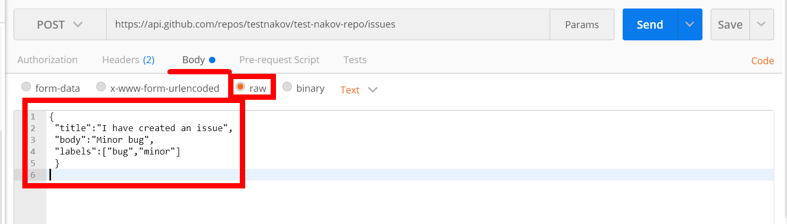

You need to use your GitHub **account credentials** to submit issues. Under the Authorization tab, select Basic and enter your username and password. Send the request to the URI from the previous task, but without the :id.

## 4. XHR (XmlHttpRequest)

Your task is to **write** a JS function that **loads** a github repository **asynchronously with AJAX**. You should **create** an instance of **XmlHttpRequest** and attach an **onreadystatechange** event to it. (An EventHandler that is called whenever the readyState attribute changes). In your event handler, when the **readyState** attribute reaches a value of **4** (it is ready), replace the text content of a **div** element with **id "res"** with the value of the **responseText** property of the request. **Do not format** the response in any way.

[More on XmlHttpRequest.open()](https://developer.mozilla.org/en-US/docs/Web/API/XMLHttpRequest/open)

Skeleton will be provided in the **Resources** folder.

### Examples



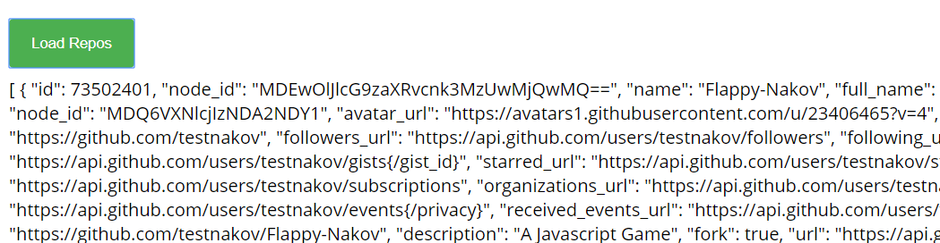

## 5. Github Repos

Your task is to **write** a JS function that **executes** an **AJAX** request with **Fetch API** and loads all user **github repositories** by a given username (taken from an input field with **id "username"**) into a **list** (each repository as a **list-item**) with **id** "**repos**". Use the properties full_name and html_url of the returned objects to create a link to each repo’s GitHub page. If an **error** occurs (like 404 “Not Found”), **append** to the list a list-item with **text** the current instead. Clear the contents of the list before any new content is appended. See the **highlighted lines** of the skeleton for formatting details of each list item.

Skeleton will be provided in the **Resources** folder.

### Examples

